Software Development Unit 1, 2.3

Anna Legaspi

# I can assess the strengths and weaknesses in my final work

|  |  |
| --- | --- |
| **Personal Critique** | |
| **Items** | **Critique** |
| Format  Fonts and font colour choice is accessible to audience | **Strengths**  Since my content (my art) is predominantly in Black and White, I also decided to keep the same colour theme in my website.  *Font style:* Amatic or Calibri; white or gray in colour  *Background:* Black or gray  **Weaknesses**  A part of me wonders if the font Amatic is an obscure font and if it is accessible to the audience. I also wonder if the black background is too flat and I might need to create more texture. |
| Layout & Structure  *Line spacing and use of columns. Are items displayed appropriately.*  *Can audience navigate and use the website with ease* | **Strengths**  The placement of the header, footer and navigation is consistent.  **Weaknesses**  The portfolio page has a lot more information in comparison to the other pages. This page can also expand if more art is later published in the website. I wonder if removing the height limitation for the inner content is better than having a scrollbar div.  If the website were to be opened in a mobile phone or tablet, the audience will have to scroll around to see the website. A possible solution is to create the website in Bootstrap. |
| Accuracy  *Correct use of Information, references, copyrights* | **Strengths**  There are no spelling or grammatical mistakes since I reviewed this before.  **Weaknesses**  I haven’t properly credited Studio Ghibli in my drawings. I also used an image online for my background and will need to either give credit or replace with a different background altogether. |
| Quality  *Quality of images and navigation buttons* | **Strengths**  I’ve already taken into consideration the sizes of my images so I don’t have any excessively low-resolution or high-resolution images.  **Weaknesses**  I feel like I could’ve created a better header image. |
| Loading times  *How long for webpage to load* | If my website were already published, I would be able to check the speed each webpage loads up. I can use a variety of tools like DevTools within Chrome or Edge or even a third-party website like <https://tools.pingdom.com/>. |
| Presentation  *Overall impression with website* | Overall, I believe the website is user-friendly. I could make a few changes to improve on it as already mentioned. |
| Any other thoughts | If I were to upload art work that is no longer black and white, it might completely throw off the theme of the website. But if there are no further works to upload, the colour theme remains intact. |

I’ve asked someone who is familiar with web design to critique my work. They used Safari as their web browser to check and provided the following feedback.

|  |  |
| --- | --- |
| **Peer Critique** | |
| **Items** | **Critique** |
| Format  Fonts and font colour choice is accessible to audience | **Strengths**  I like the font used for the menu, colour choice is strong and effective in getting attention  **Weaknesses**  I would NOT use the font (Roman text?) for the main body on your ‘About Me’ page. It somehow does not look right.  It may be better to use the fonts used on the menu as your body text as well, then change ‘ANNA LEGASPI ART’ into something bolder and louder.  Try to subdue the WHITE font to a ’soft gray’ just so the contrast is not blaring.  Try to make your photo B&W? It could create a more powerful statement |
| Layout & Structure  *Line spacing and use of columns.*  *Can audience navigate and use the website with ease* | **Strengths**  Great to navigate, easy to understand  **Weaknesses**  Layout can be tweaked on some pages.  Portfolio is good and straight forward.  The Utube demo is inspirational  Suggestion: ‘About Me’ page   * Align text to left and either from the top or bottom of your photo; this will look neater. * Try moving your photo closer to the left margin, and either align it with the top or bottom of the menu box. If you’re aligning from the top, align text to the bottom of the photo, if aligning from the bottom, bring text aligned to top of photo.   Suggestion: ‘Contact’ page   * Again move box closer to the left margin of the menu 2. Make the box a bit bigger. * Use same fonts as the menu |
| Accuracy  *Correct use of Information, references, copyrights* | **Strengths**  Accurate information, adequate, clear and not overbearing.  **Weaknesses**  NA |
| Quality  *Quality of images and navigation buttons* | **Strengths**  Well composed, confident  **Weaknesses**  Just the tweaks for aesthetics |
| Presentation  *Overall impression with website* | **Weaknesses**  I like the background, but can be a bit too much to the eye. Try reducing the opacity of your background to take the eye to the centre. |
| Any other feedback | None |

Following the receipt of the feedback, I asked if they can provide me with screenshots since it didn’t add up to what I already have. I then found out that my website displayed differently in Safari.

# Screenshots from Safari

## Contact page

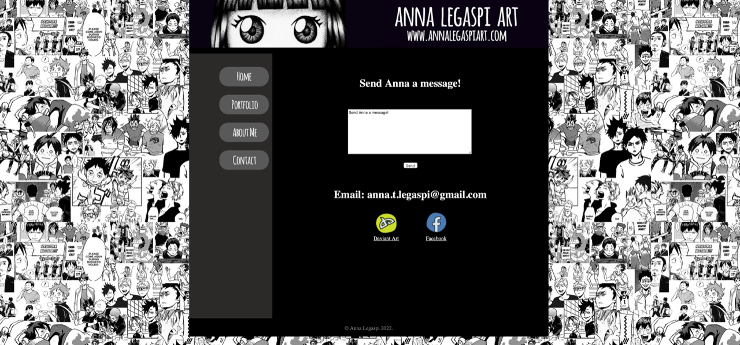

## About me page

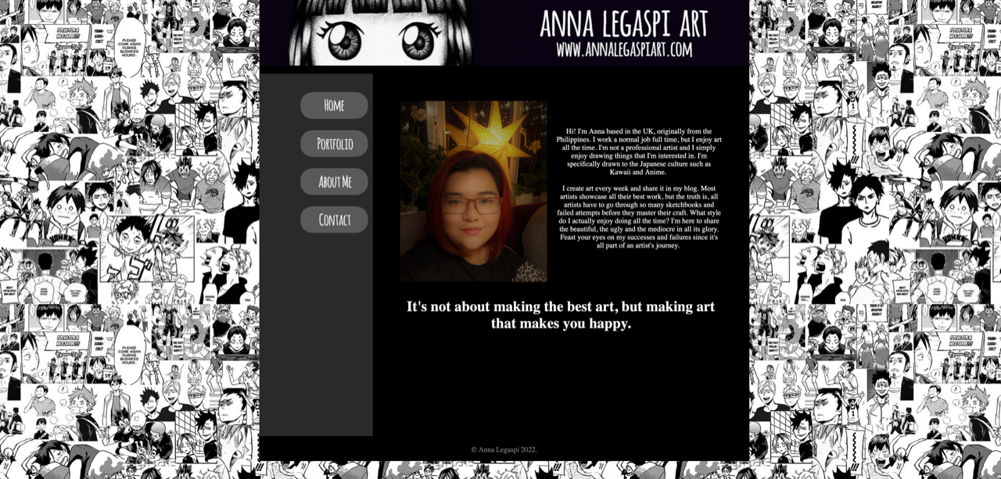

## Portfolio page

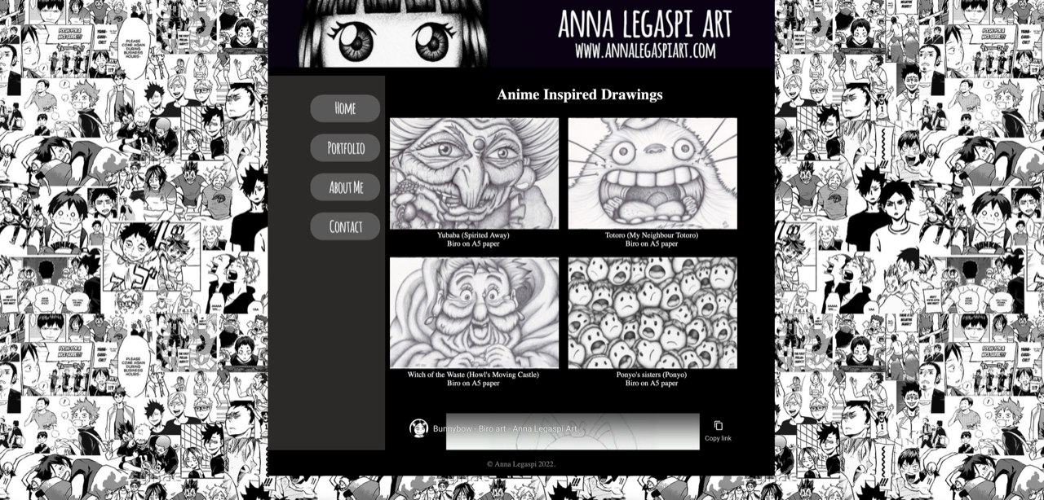

I’ve also noticed that the scroll bar didn’t exist in Safari.

## Home page

